|  |
| --- |
| **SIDDARTHA INSTITUTE OF SCIENCE AND TECHNOLOGY:: PUTTUR**  (AUTONOMOUS)  Siddharth Nagar, Narayanavanam Road – 517583  **QUESTION BANK (DESCRIPTIVE)**  **Subject with Code :** Electrical Circuits – I (18EE201) **Course & Branch**: B.Tech– EEE  **Year &Sem:** I-B.Tech & II-Sem **Regulation:** R18 |

**UNIT –I**

**INTRODUCTION TO ELECTRICAL & MAGNETIC CIRCUITS**

1. (a)Three resistances 2Ω , 4Ω and 6Ω are connected in series across a voltage supply voltage across 2 Ω resistor is 4V. Find the voltage across remaining resistances and total voltage.

(b) Find the current supplied by 10V battery by using star-Delta transformation.



1. For the figure shown, calculate the equivalent resistance of the following combination of resistors and also calculate the source current, total power dissipated.



|  |
| --- |
| 1. **C:\Users\RADHA\Desktop\Capture1.PNG**Obtain the node voltages for the following network shown in figure. |

1. Determine the current through 800 ohm resistor in the network shown in fig.

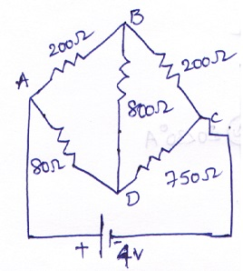

1. Determine the mesh currents I1 AND I2 for the circuit shown below.

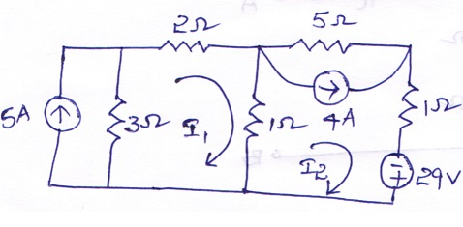

1. a) Derive the expression for Delta connected resistances in terms of Star connected resistances?

b) What are the types of sources? Explain them with suitable diagrams and Characteristics?

1. Find the current in the 5Ω resistor in the network shown in figure 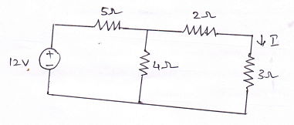

1. Find the equivalent resistance across the terminals A and B of the network shown in fig using Star-delta transformation.

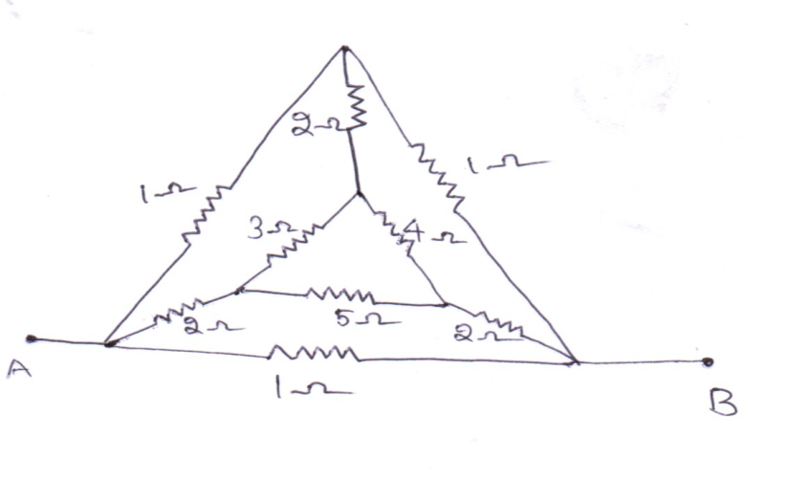

1. Find the current passing through each resistor for the circuit below in fig (3).

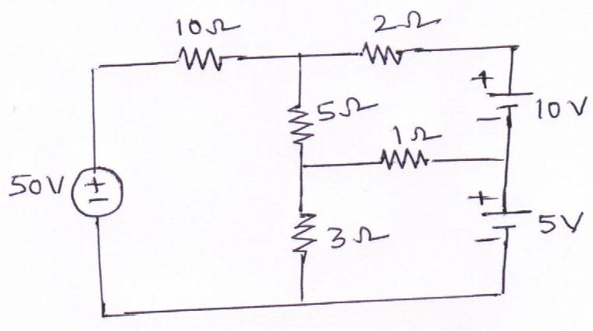

1. Determine the voltages at each node for the circuit shown in figure (5).

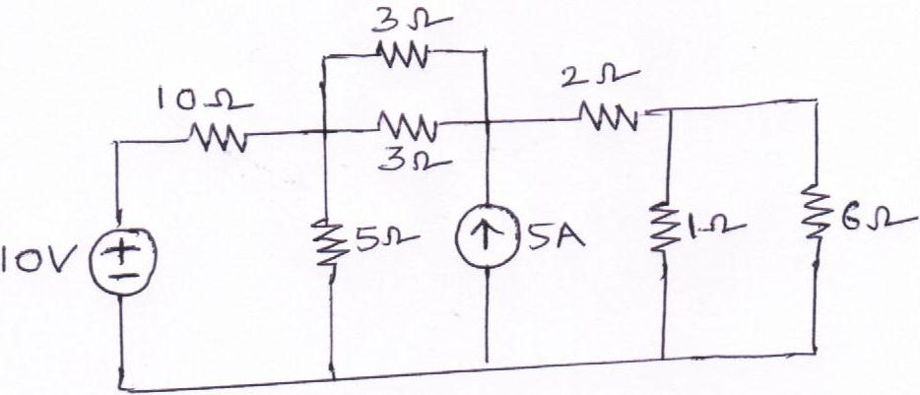

**UNIT-II**

**SINGLE PHASE AC CIRCUITS**

1. An alternating current is expressed as I = 14.14 sin 314t. Determine.

i. Maximum current ii. rms current iii. Frequency

iv. Instantaneous current when t = 0.02msec.

2. Derive an expression for the current, impedance, average power for a series RC circuit excited by a sinusoidally alternating voltage and also _nd the power factor of the circuit. Draw the phasor diagram.

3. a) A series R-L series circuit having a resistance of 4 and 3 ohms inductive reactance is fed by

100V, 50Hz, 1- Φ supply. Find current, power drawn by the circuit and power factor.

b) What is admittance? Which are its two components? State its unit. How the admittance is

expressed in rectangular and polar form?

4. The impedance of a parallel circuit are Z1 = (6+j8)Ω and Z2= (8-j6)Ω. If the applied voltage is 120V, find

1. Overall current and power factor of the circuit
2. Current and power factor of each branch
3. Power consumed by each impedance
4. A series circuit consisting of a 10Ω resistor, a 100μF capacitor and a 10 mH inductor is driven by a 50 Hz a.c. voltage source of maximum value 100 volts. Calculate the equivalent impedance, Current in the circuit, the power factor and power dissipated in the circuit.
5. The fullwave rectified sine wave shown in fig has a delay angle of 600. Calculate Vavg and Vrms.

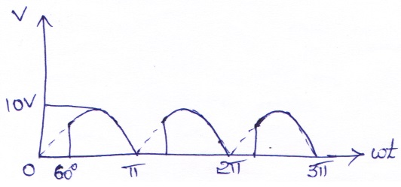

1. a) A series RL circuit having a resistance of 4Ω and inductance reactance 3Ω is connected to

100V, 50Hz, single phase supply. Find the current, power drawn by the circuit and power

factor.

b) A Capacitor of 1μF is connected across an AC Voltage of V=170 sin (400t). Determine (a)

Capacitive Reactance (b) Sinusoidal expression for current (c) Maximum current.

1. A resistance of 50Ω, inductance of 29.8mH, Capacitance of 3.4μF Capacitor are connected in series across a 200V, 250HZ AC Supply. Find (a) Impedance of circuit (b) Current (c) Power consumed in the circuit (d) Power factor (e) Voltage drop across resistance (f) Voltage drop across Inductance (g) Voltage drop across Capacitance. Also draw the phasor diagram for the circuit.
2. A 1KΩ resistor is connected in series with an inductance of 50mH across a 230V, 50HZ AC Supply. Find (a) Inductive reactance (b) Impedance (c) Current (d) Phase angle (e) Voltage drop across resistance (f) Voltage drop across Inductance.
3. A 50Ω resistor is connected in series with a 25μF Capacitor across a 230V, 50HZ AC Supply. Find (a) Capacitive reactance (b) Impedance (c) Current (d) Phase angle (e) Voltage drop across resistance (f) Voltage drop across Capacitance (g) Power Factor.

**UNIT-III**

**NETWORK THEOREMS**

1. Find the current through 12Ω resistor using superposition theorem.



1. For the circuit shown in figure , find the value of current through 1 ohm in the arm PQ using Thevenin's theorem.



1. When the load impedance R draws the maximum power? Find the maximum powerdelivered to the load by using maximum power transfer theorem for the given network.

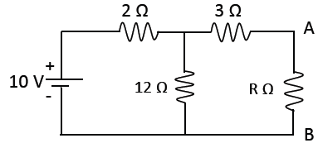

1. Find the Norton’s equivalent circuit across X-Y for the network shown in fig.

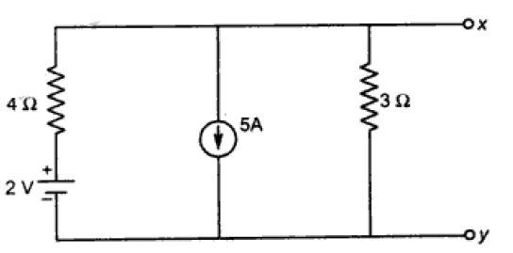

1. Using Thevenin’s theorem find current in the network

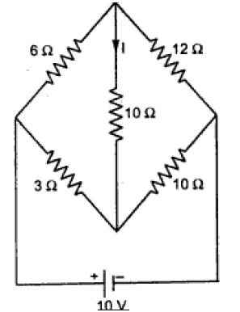

1. Find the load current using Milliman’s theorem. And all values are in ohms

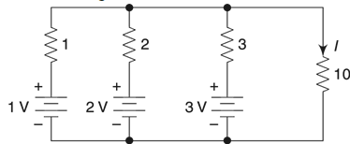

1. Verify reciprocity theorem.

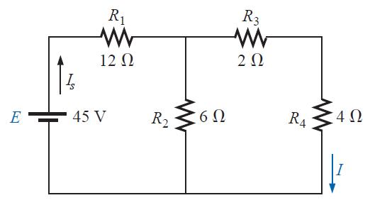

1. Determine the voltage across (2+j5)Ω impedance as shown in fig. by using the superposition theorem.

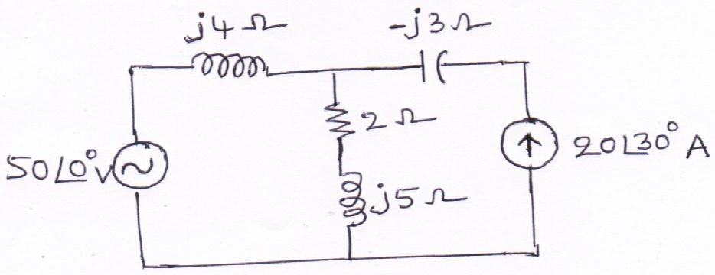

1. For the circuit shown in fig. determine Thevenin’s equivalent between the output terminal.

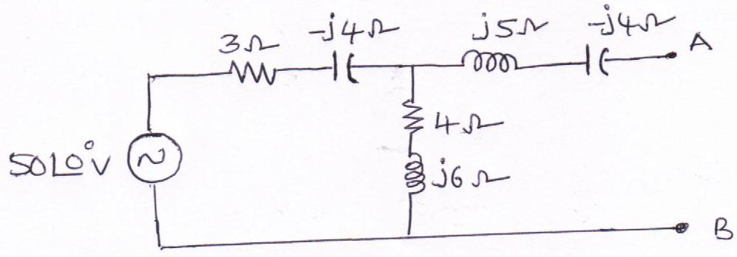

10. Derive the condition for the maximum power to be transferred from the source to the load.

**UNIT-IV**

**LOCUS DIAGRAMS & RESONANCE**

1. Show that the locus of the current in an R-L circuit with R variable is a semicircle. Find the

radius and the center of the circle.

2. Determine the value of undamped natural frequency of oscillations of a RLC

circuit with R = 10 ohms, L = 4H, C = 6F.

1. (a) Obtain the current locus of a series circuit having a fixed resistance and a variable

inductance.

(b) Given a series RLC circuit with R = 100 ohms, L = 0.5 H and C = 40F, calculate the resonant, lower and upper half – power frequencies.

4. a) Draw and explain locus diagram of RC parallel circuit?

b) Draw and explain locus diagram of RL parallel circuit?

5. A coil having an inductance of 50 mH and resistance 10 Ω is connected in series with a 25

capacitor across 200 V AC supply. Calculate:

(i) Resonant frequency of the circuit. (ii) Current flowing at resonance. (iii) Quality factor.

6. In the parallel RLC circuit, calculate resonant frequency, bandwidth, Q- factor.

7. Explain resonance in series circuit?

8. For the RLC series circuit R= 50Ω, L=0.03H, C=100μF. Determine the frequency at which the circuit resonates. Also find the quality factor, voltage across the inductance, voltage across capacitance at resonance.

9. Explain locus diagrams of RLC series circuit?

10. a) Draw the Locus diagram of a Series RL Circuit?

b) Draw the Locus diagram of a Series RC Circuit?

**UNIT-V**

**MAGNETIC CIRCUITS**

1. (a) What is an electric circuit? What is a magnetic circuit? Make a comparison between electric

circuit and magnetic circuit.

(b) Coil 1 of a pair of coupled coils has a continuous current of 5 A and the corresponding fluxes

φ11 and φ12 are 0.2 and 0.4 m Wb respectively, if the turns are N1 = 500 and N2 =1500, find L1,

L2, M and k.

2. (a) Explain active elements in detail.

(b) A pure inductance of 3 mH carries a current of the wave form shown in figure. Sketch the

waveform of V (t) and P (t). Determine the average value of power.

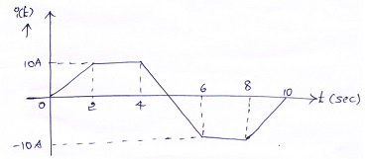

3. (a) Define and explain self – inductance and mutual – inductance.

(b) Two coupled coils of L1 = 0.8 H and L2 = 0.2 H have a coupling coefficient k = 0.9. Find the

mutual inductance M. Derive the expression used.

4. (a) State and explain Faraday's laws of electromagnetic induction.

(b) The number of turns in a coil is 250. When a current of 2 A flows in the coil, the flux in the coil

is 0.3 mWb.When the current is reduced to zero in 2 ms, the voltage induced in a coil lying in the

vicinity of the coil is63.75 V. If the co-efficient of coupling between the coils is 0.75, find: (i) The

self-inductance of the two coils.(ii)Mutual inductance. (iii) Number of turns in the second coil. (iv)

Derive the formulae used.

5. A coil of 100 turns is wound uniformly over a insulator ring with a mean circumference of 2m

and a uniform sectional area of 0.025cm2. If the coil is carrying a current of 2. Calculate

1. the mmf of the circuit (b) magnetic field intensity (c) flux density (d) total flux.

6. Explain Self Inductance, Mutual Inductance and Co-efficient of coupling in detail? Give the

relation between L1, L2, K & M?

7. Explain in detail about Statically Induced emf and Dynamically Induced emf?

8. Derive the expression for MMF for a composite series magnetic circuit?

9. Derive the expression for equivalent inductance when the coupled inductors are connected in

Parallel aiding and parallel opposition?

10. Two coupled coils with L1=0.02H, L2=0.01H and K=0.5 are connected in four different ways

Series aiding, series opposing, parallel aiding and parallel opposing. Determine the equivalent

Inductances in all the four cases?

Prepared by: **K. BABU**